# DRIVER AWAKE SYSTEM

Authors:[Maanasapriya.M],[Madhumitha.J],[Prinkayatthra D],[Kanmani.D]

Affiliation:[Rajalakshmi Engineering College]

## Abstract

One of the major reasons for road accidents is driver fatigue, particularly on long trips or under night driving conditions. The purpose of this project is to design an appropriate Driver Fatigue Detection System in order to enhance road safety through real-time detection of driver drowsiness.

The system tracks the driver's alertness through head movements and blink rate. Whenever the system detects drowsiness, it activates a high-pitched alarm to alert the driver and activates the vehicle's flash parking lights to alert other traffic. The double-alarm system greatly minimizes the chances of accidents caused by drowsy driving, making road conditions safer for everyone.

## Introduction

Driver drowsiness is one of the main causes of road accidents, especially in longdistance driving or night driving. Drowsy drivers getdistracted and react slowly, and this result s in dangerous roadconditions.

This project proposes a Driver Fatigue Detection System that tracks the eye movement and facial expressions of the driver round the clock through a camera. When it senses drowsiness, an inbuilt alarm goes off to alert the driver, and car lights flash outside to alert other drivers. This two-level warning system is designed to prevent accidents and provide safer driving conditions.

## Literature Survey

Driver drowsiness detection has been of significant interest in traffic safety research due to its potential to avoid road accidents. Techniques available so far to track driver alertness have been categorized into three broad categories: physiological, behavioral, and vehicle-based methods.

Physiological methods involve monitoring of biological signals like EEG

(Electroencephalogram) to record brain activity, EOG (Electrooculogram) to detect movement of the eyes, and heart rate variability. The methods are precise but are contact sensors, therefore not very practical for daily use.

As a more practical solution, non-intrusive behavior monitoring methods have become popular. These methods examine visual signals such as eye blinking, facial expressions, and yawning patterns. For instance, Ji et al. (2004) developed a real-time system with eye tracking and head movement detection based on the PERCLOS (Percentage of Eye Closure) measure, a wellestablished measure of drowsy drivers.

As computer vision and machine learning improve, behavioral systems have become more accurate and intuitive, and they are now suitable for practical automotive applications. The technologies provide real-time feedback and anticipatory safety, and they play a significant role in preventing accidents.

## System Architecture

The four core modules of the Driver Fatigue Detection System can collaborate to identify and respond to driver fatigue indicators.

1. Input Unit

* A camera mounted on the dashboard captures the driver's face at all times.
* It monitors significant visual cues such as blink rate, eye closure, and head position.

2. Processing Unit

* A microcontroller or mini-computer (such as Arduino or Raspberry Pi) processes the camera input.
* It performs image-processing algorithms to detect signs of fatigue, such as excessive eye closure or excessive blinking.

3. Output Unit

* If drowsiness is sensed, a built-in buzzer warns the driver.
* Simultaneously, external parking lights start blinking to warn other road users.

4. Alert Mechanism

* Internal Alert: A loud high-pitched tone is generated to warn the driver.
* External Alert: Flashing vehicle lights notify surrounding drivers of the potential danger.

This double-alert system makes sure that both the driver and other road users are alerted instantly to a hazard.

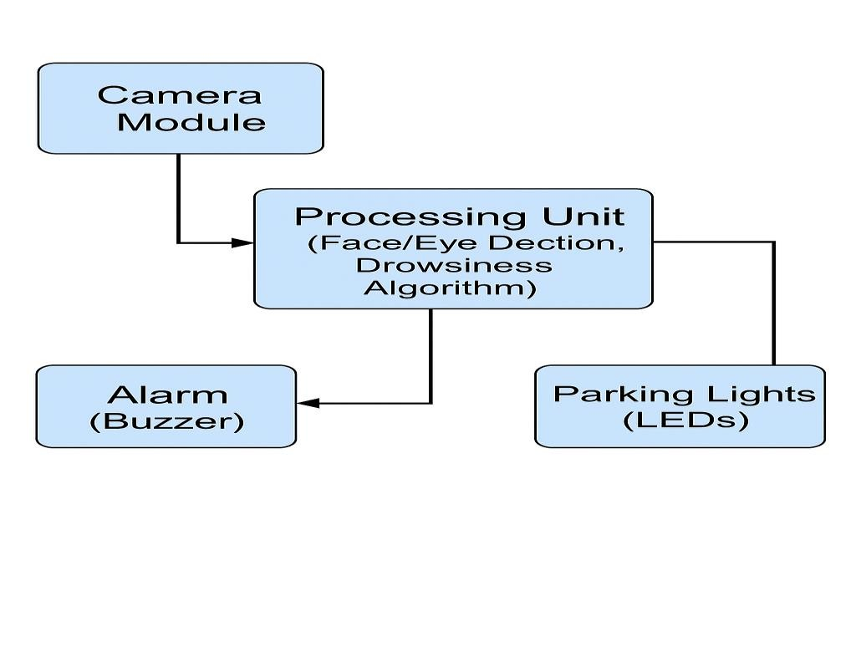

## System Implementation

The system is designed by combining hardware and software components that work together to monitor and respond to driver drowsiness.

1. Hardware Elements

* Camera Module: Records real-time video of the driver's face.
* Microcontroller/Processor: Processes the images (e.g., Raspberry Pi or Arduino).
* Buzzer/Alarm: Produces an audible sound on detecting drowsiness.
* LED Parking Lights: Flashing to visibly inform other motorists.

2. Software Components

* Python: Main programming language to integrate and maintain the system.
* OpenCV: A vision library that identifies the face and eyes of the driver from the video stream.
* Dlib / Haar Cascades: Eye tracking software to detect eye positions and movements.
* Threshold Algorithms: Determines the duration of closed eyes to detect symptoms of drowsiness.

3. Drowsiness Detection Logic • Face and Eye Detection: Monitors the driver's face and eyes continuously using video analysis.

* Eye Aspect Ratio Calculation (EAR): Measures how open the eyes are; low EAR for several frames signifies drowsiness.
* Threshold Checking: If the EAR is below a certain value for a certain number of frames, drowsiness is confirmed.

•Trigger Alerts: Upon detection: oThe buzzer will ring to inform the driver. oThe parking lights flash to alert other travelling traffic.

4. Integration and Testing •All components are assembled and configured.

* The software is also tested under different light and fatigue conditions to confirm detection accuracy.
* Optimizations are done to enhance real-time performance and quality prior to deployment.

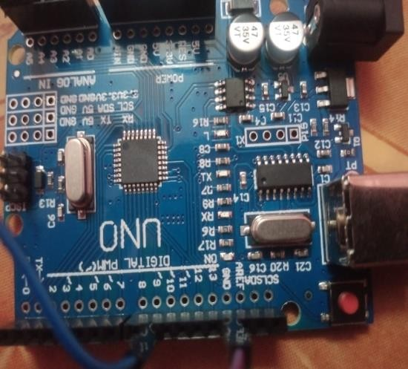 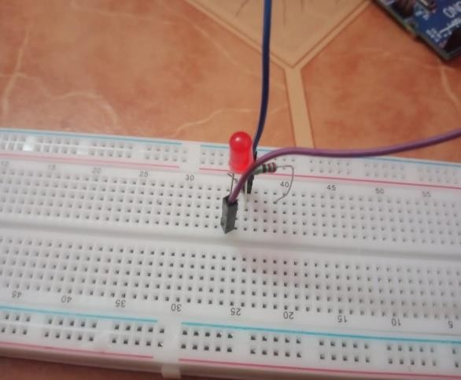

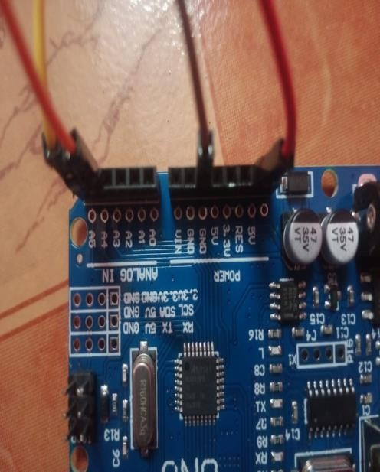 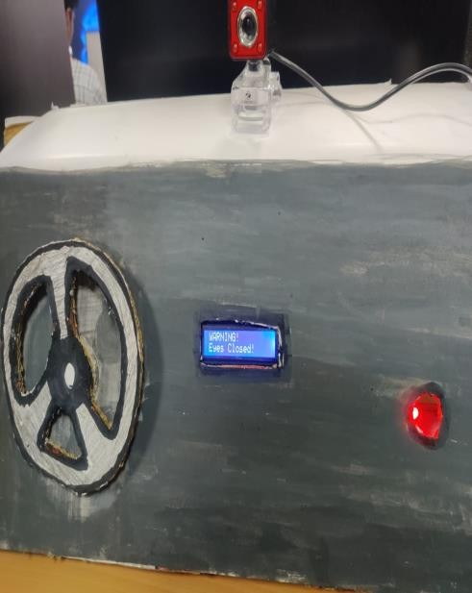

 

# Conclusion

This project suggests an efficient and effective driver drowsiness detection system to reduce the risk of road accidents caused by drowsiness. Utilizing visual cues such as eye closure and blink rate, the system detects drowsiness and warns through audio and visual signals.

The system is inexpensive, easy to install, and can be installed on most vehicles without any major alterations. Aside from protecting the driver, the system also alerts other traffic in the vicinity, contributing to road safety in general. With more research and testing, the system can be a valuable resource for fleets of commercial and private vehicles alike, providing a smart safety feature for modern transport.

# Reference

1. W. W. Wierwille, L. A. Ellsworth, “Evaluation of driver drowsiness by trained raters,” *Accident Analysis & Prevention*, vol. 26, no. 5, pp. 571-581, 1994.
2. T. A. Dingus et al., “Driver crash risk factors and prevalence evaluation using naturalistic driving data,” *PNAS*, vol. 113, no. 10, pp. 2636–2641, 2016.
3. Q. Ji, Z. Zhu, and P. Lan, “Real-time nonintrusive monitoring and prediction of driver fatigue,” *IEEE Transactions on Vehicular Technology*, vol. 53, no. 4, pp. 1052-1068, 2004.
4. E. A. Johns, “Detection of driver drowsiness using PERCLOS and image processing,” *International Journal of Scientific and Research Publications*, vol. 3, no. 1, pp. 1–5, 2013.
5. B. S. Awais, N. M. Badruddin, and M. Saad, “Driver drowsiness detection using EEG signal analysis,” *IEEE 9th International Conference on Information Technology*, 2015.
6. R. R. Reddy et al., “Drowsiness detection using eye-blink patterns and machine learning,” *Procedia Computer Science*, vol. 171, pp. 857-864, 2020.
7. S. Singh, “Critical reasons for crashes investigated in the National Motor Vehicle Crash Causation Survey,” *NHTSA Traffic Safety Facts*, 2015.
8. A. Vural et al., “Drowsy driver detection through facial movement analysis,” *IEEE Conference on Human Factors in Computing Systems*, 2007.
9. M. Bergasa et al., “Real-time system for monitoring driver vigilance,” *IEEE Transactions on Intelligent Transportation Systems*, vol. 7, no. 1, pp. 63-77, 2006.
10. A. Abtahi, Z. Omidyeganeh, and L. Shirmohammadi, “YawDD: A yawning detection dataset,” *ACM International Conference on Multimedia*, 2014.